Meet Our Parents
Showcase of minimum 3 testimonials from parents. Each will link to the full content.
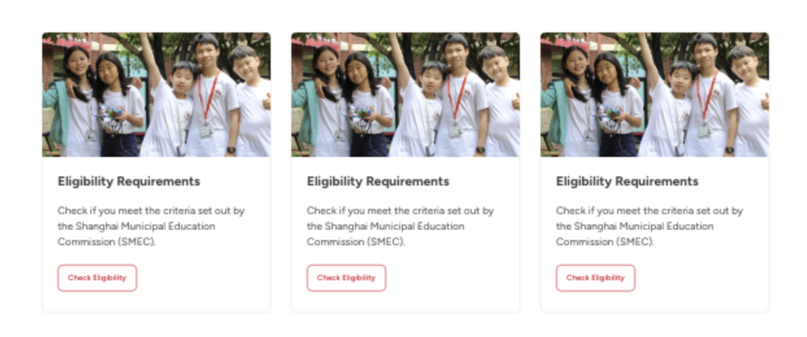

No. | Article Title | URL
1. | Dulwich Voices：What makes a school thrive? | Episode 1 | https://suzhou.dulwich.org/dulwich-life/dulwich-voices-what-makes-a-school-thrive-episode-1
2. | Dulwich Voices：What makes a school thrive? | Episode 2 | https://suzhou.dulwich.org/dulwich-life/dulwich-voices-what-makes-a-school-thrive-episode-2
3. | Dulwich Voices：What makes a school thrive? | Episode 3 | https://suzhou.dulwich.org/dulwich-life/dulwich-voices-what-makes-a-school-thrive-episode-3

Display community scroller focusing on happy parents – minimum 6 parents (2 DUCKS, 2 JS, 2SS)
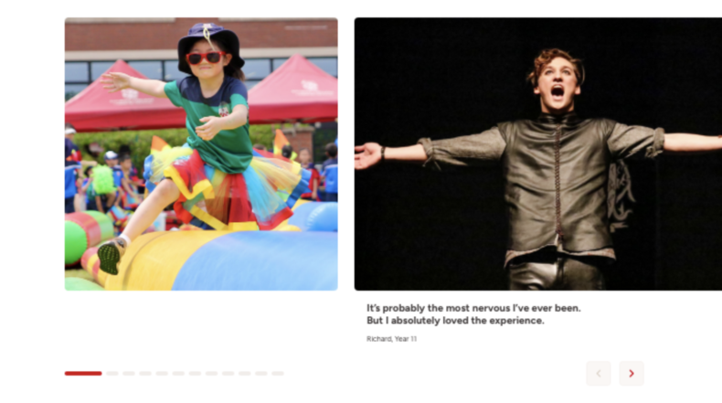

Content needed for community scroller:
No. | Parents Name | Image (The parent should be in the middle of the photo) | Short quote (15-35 words)
1. | Steve_Y2&Y5 | Hi-res image, 1920 x 1080 | I’m happy to join FoD committee, which is a bridge connecting parents and school.
2. | Shen_Y4 | Hi-res image, 1920 x 1080 | I’ve met a bunch of parents they’re passionate and creative, always be willing to contribute for the school and community.
3. | Nancy_Y5 | Hi-res image, 1920 x 1080 | Parents are from diverse countries and regions contribute their professional expertise, resources to spark even more exciting possibilities for our community.
4. | Shanker, Year 13 | Hi-res image, 1920 x 1080 | Welcoming, nurturing, and engaging
5. | Amy_Y9 | Hi-res image, 1920 x 1080 | Warm, Trustworthy, and Reverse.
6. | Candy_Y9&12 | Hi-res image, 1920 x 1080 | Dulwich is a place for inclusion, diversity and creativity. Together we want to help the school make it a better place for parents and students.

